* 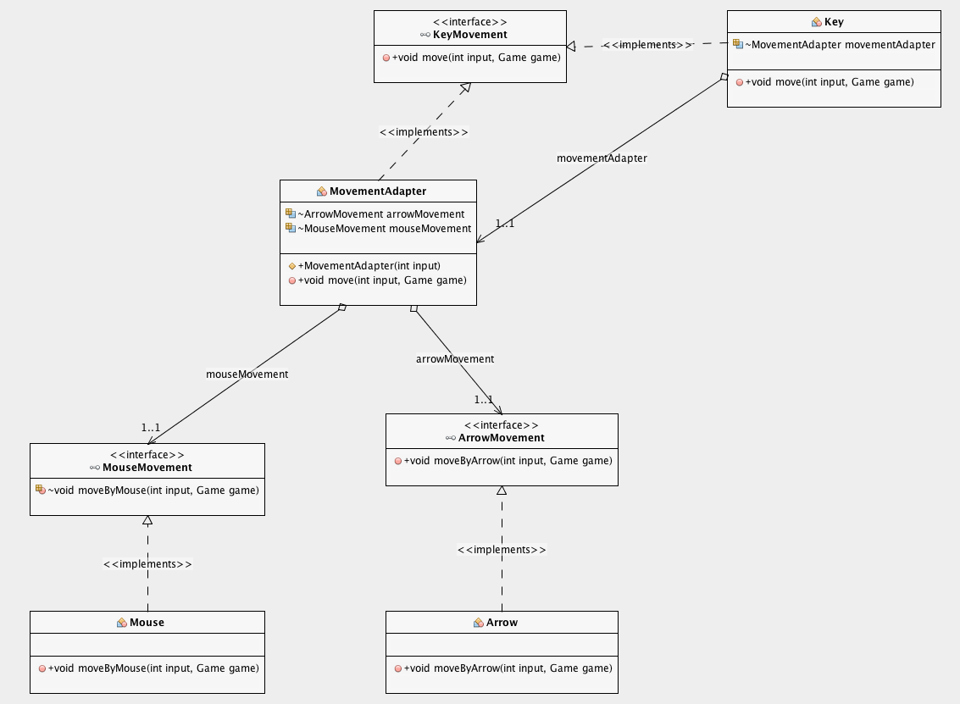**Adapater pattern**

**Motivation**

Adapter pattern is used as a bridge between two incompatible interfaces. This type of design pattern comes under structural pattern as this pattern combines the capability of two independent interfaces. Abstract class MovementAdapter is used to make a connection between two independent interfaces having functions about changing the coordination of Pacman. As a result, user is allowed to move the pacman by using keyboard and mouse.

**Implementation**

Concrete class Key contains the MovementAdapter class as well as the move() method detecting the key input and either calls the adapter or runs the functionality.Movement adapter implements the KeyMovement interface and initialize the independent MouseMovement or ArrowMovement interface according to the input given and calls either moveByArrow() or moveByMouse() method.

**Outcomes**

Consequently, adapter pattern has led to high compability to join functionalities of independent or incompatible interfaces in a single class easily.